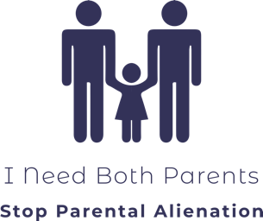

PHOTO RELEASE FORM

I, ……………………………………………………………………………………………………….. (the “Releasor”) grant permission and consent to Florence Burrows, founder of the organization “I Need Both Parents” (the “Releasee”) for the use of the following photograph as identified below for presentation under any legal condition, including but not limited to: publicity, copyright purposes, illustration, advertising and web content:

Description: Picture of the releasor, to be used in a movie to raise awareness of the public about parental alienation and its victims.

Payment:
The Releasor understands that there shall be no payment for this release.

Royalties:
The Releasor understands that no royalty, fee, or other compensation shall become payable the Releasor by reason of such use.

Revocation:
The releasor understands that he or she may revoke this authorization at any time by notifying the Releasee in writing. The revocation will not affect any actions taken before the receipt of this written notification.
Images will be stored in the personal computer of the Releasee and only her will have access to them. They will be kept as long as they relevant for regular updates of the movie called “The Faces of Parental Alienation Victims.” The pictures will be destroyed or archived after that time.

We, the Releasor and Releasee, understand and agree to the aforementioned terms and conditions.

Releasor Signature: Date:

Print Name

Releasee Signature: Date:

Florence Burrows, representing “I Need Both Families”

